Anthropogenic Disturbance Mapping across Boreal Woodland Caribou (Rangifer tarandus caribou) Ranges in Canada -

Summary of Mapping Process

As part of a project that aimed at providing a scientific assessment of critical habitat for boreal woodland caribou (see Environment Canada 2011), Environment Canada’s Landscape Science and Technology Division was tasked with providing detailed anthropogenic disturbance mapping across known caribou ranges. This data allowed researchers to better understand the attributes that have a known effect on caribou population persistence. The mapping process was established to create a nationally consistent, reliable and repeatable geospatial dataset that followed a common methodology. The methods developed were focused on mapping disturbances at a specific point of time, and were not designed to identify the age of disturbances, which can be of particular interest for disturbances that can be considered non-permanent, for example cutblocks. The type of analyses developed using the resultant datasets included caribou resource selection functions and habitat modelling.

This document provides a summary of the methods used for mapping disturbance. Full detailed methods can be found in Appendix 7.2 of the report entitled Scientific Assessment to Inform the Identification of Critical Habitat for Woodland Caribou (Rangifer tarandus caribou), Boreal Population, in Canada: 2011 Update (Environment Canada 2011).

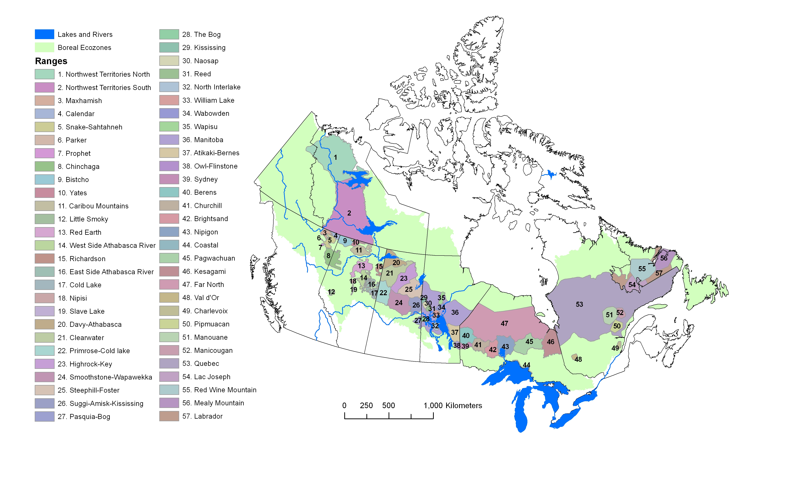
Figure 1. Boreal caribou ranges across Canada defining areas that were mapped.
Anthropogenic disturbances within 57 caribou ranges across Canada were mapped. The ranges (Figure 1) were defined by individual provinces and territories across Canada. Disturbances were mapped across these ranges using 2008-2010 satellite imagery to provide the most up to date data possible.

Satellite Imagery and Minimum Mapping Unit
Landsat 5 satellite imagery was selected for this project as the imagery provided enough spatial detail to identify disturbance features and provided full coverage of the areas of interest, usually with multiple dates available. The spatial resolution of all Landsat imagery used was 30 m x 30 m with a positional accuracy of 50 m RMS (root mean square error). Imagery was sourced from the US Geological Survey (USGS) archived image library.

Within the context of this project, anthropogenic disturbance was defined as any human-caused disturbance to the natural landscape that could be visually identified from Landsat imagery at a viewing scale of 1:50,000. The use of a medium resolution sensor such as Landsat limited the size of features that could be seen and extracted, which was particularly evident in the underestimation of narrow seismic exploration lines. As well, the limited spectral information provided by an optical sensor prevented differentiation between different seral stages of forests. Harvesting in some areas was most certainly missed as a result of regeneration and partial cutting, which after a certain time period made cutblocks no longer visible in the imagery. A minimum mapping unit (MMU) of 2 ha or approximately 22 contiguous Landsat pixels was selected. The only exception to this rule was well sites that were widespread across the western boreal but were smaller than the MMU and therefore represented by a 100 m diameter circle or 0.785 ha, matching the approximate footprint of well sites on the ground. No standard minimum separation distance that would identify a disturbance as unique from neighbouring disturbances was established between mapped polygonal features, resulting in some interpreter variability. For linear features, a separation distance of approximately 100 m was typically used.

Disturbance Features
Each disturbance feature type was represented in the database by a line or polygon depending on their geometric description. Polygonal disturbances included: Cutblocks, mines, reservoirs, built-up areas, well sites, agriculture, oil and gas facilities, as well as unknown features. Linear disturbances included: Roads, railways, powerlines, seismic exploration lines, pipelines, dams, air strips, as well as unknown features. For each anthropogenic feature type, a clear description was established (see Appendix 7.2 in Environment Canada 2011) to maintain consistency in identifying the various disturbances in the imagery by the different interpreters.

Use of Ancillary Data
Various ancillary vector datasets were used as aids in detecting, classifying and digitizing disturbances on the Landsat imagery. While ancillary data was used to guide interpretation and feature labelling, since the ancillary data was often variable across the country in terms of completeness as well as scale, features were only digitized if they were clearly visible in the Landsat imagery at a viewing scale of 1:50,000. To avoid unnecessary duplication, the Global Forest Watch Canada reservoir dataset (GFWC, 2009) was burned in as a result of the complex nature of reservoir bounds, and the difficulty in identifying reservoirs compared with other water bodies.

General Disturbance Mapping Process
ArcGIS 9.3 and 10.0 was used for all geodatabase creation and data collection, with ArcInfo license (ESRI 2009; 2010) used for all topology building. The following general steps were followed for the collection of disturbance features within a local population range:
- Disturbances were collected within file geodatabases, incorporating both linear and polygonal features. Each collected feature was tagged with a disturbance type, along with the date of imagery used, the interpreter's initials, as well as additional comments and whether or not the feature was verified with ancillary data.
- Landsat imagery used (May to September) was selected to either match the dates of demographic data available for a particular area, and as recent as possible (2008-2010) for all ranges.
- A standard viewing scale of 1:50,000 was used with a grid for following progress.
- Upon completion of all grid cells, a full review was carried out at viewing scale of 1:100,000 to identify any obvious errors of omission.
- A quality control (QC) process was carried out involving a second independent interpreter, who examined the work and added missing disturbances as well as ensuring completeness and accuracy of attribute table information.
- Disturbance data was post-processed to ensure topological consistency and that the dataset followed a set of standardized GIS rules associated with line / polygon geometry.

Quality Assessment of Disturbance Mapping
An intense quality assessment of the dataset was carried out in order to quantify and categorize error including any variation and interpreter bias attributed to the manual digitizing process. Specifically, this assessment evaluated errors of omission and commission in both linear and polygon disturbance features in the western and eastern boreal forest. Previously collected disturbance data was compared to newly collected data from higher spatial resolution GeoBase Orthoimage SPOT 4 and SPOT 5 imagery (generally within one year of the Landsat imagery used for the original collection) with a ground based pixel size of 10m in the panchromatic band and 20m for the multispectral bands. Disturbances across selected areas were collected and compared within 5 km x 5 km sample landscapes covering a total of approximately 7500 km² of boreal forest spatially dispersed over a range of disturbance conditions, landscape type and image quality. Four individual interpreters with at least 6 months of experience in disturbance mapping took part in the quality assessment, each digitizing all sampled cells. Interpreters followed the same protocol, i.e. rule sets, interpretation guidelines and feature class labelling as developed for the Landsat disturbance mapping.

Results of the quality assessment process showed the following main conclusions:
- On average there was a 62% underestimation of linear features by length in the Landsat based disturbance mapping product when compared to SPOT 4/5 imagery. Interpreter bias associated with mapping linear features was approximately +/- 10 % of this estimate.
- On average there was an 8 % overestimation of polygon features by area in the Landsat based disturbance mapping product when compared to SPOT 4/5 imagery. Interpreter bias associated with mapping polygon features was approximately +/- 8 % of this estimate.
- Interpreter bias in mapping linear features was generally more pronounced in landscapes with a high density of linear features such as those in the western boreal. There was variation in both the detection and labelling of linear features amongst the individual interpreters. Seismic, road and pipeline class types were prone to error unless associated ancillary data were available for confirmation.
- Interpreter bias in mapping polygon features was evident although less so than with linear features. Polygon features were reliably detected with less than a 1 % error of omission; however, labelling of polygons such as cutblock, mine, settlement and oil/gas class types were confused in areas with multiple disturbances. When ancillary data were available class type labelling was more reliable for polygon features, particularly for oil and gas.
- Overall patterns of individual interpreter bias were consistent across all evaluated ranges in the eastern and western boreal and for linear and polygon features. In other words, individual interpreters were making consistent decisions on a day-to-day basis regarding the mapping process, with each having their own particular bias. Interpreter variation should be considered when using the disturbance map product.

Creating Disturbance Footprint
Following a detailed sensitivity analysis of the disturbance data and its linkages with boreal caribou herd demographics, along with a literature review, a buffer of 500m radius was established as the most suitable size buffer representing the zone of influence or disturbance footprint related to caribou survival. All linear and polygonal data was buffered by 500m and the resultant polygons dissolved to create an anthropogenic disturbance footprint for each caribou range.

Forest fire polygon data (1970-2010) was merged into the anthropogenic disturbance footprint for each caribou range in order to create the overall total disturbance footprint, which was used to assess disturbance conditions within the ranges within the scientific assessment (Environment Canada 2011).

References
Environment Canada. 2011. Scientific Assessment to Inform the Identification of Critical Habitat for Woodland Caribou (Rangifer tarandus caribou), Boreal Population, in Canada: 2011 update. Ottawa, Ontario, Canada. 102 pp. plus appendices. Available at: http://www.sararegistry.gc.ca/document/default_e.cfm?documentID=2248
[accessed September 28, 2011]

Global Forest Watch Canada (GFWC). 2009. Reservoirs of Canada (DRAFT), Edmonton, AB, Global Forest Watch Canada

